**Ideation Phase**

**Define the Problem Statements**

|  |  |
| --- | --- |
| Date | 25 September 2022 |
| Team ID | PNT2022TMID07759 |
| Project Name | Inventory management system for retailers |
| Maximum Marks | 2 Marks |

**Customer Problem Statement Template:**

1) **Mismatch in goods delivery**- Mistakes in e-commerce suppliers/retailers such as

Amazon & Flipkart, deliver wrong product to a customer, irrelevant to what customers before.

2)**Wastage of resources due to stockpiling**- Which a high standard of living demands

particularly rapid consumption of new goods, many perfectly usable goods may be scrapped

or goods may be made with a built-in obsolescence.

3) **Error in data can lead to major loss to the retail company**- Data loss occurs when data is

accidentally deleted or something causes data to become corrupted.

4**) Irregular tracking system of stocks**- Irregular stocking system of orders, tracking orders is

difficult for the suppliers to track and as well as irrelevant tracking details are been

provided to the customers which leads to stockpiling and waste of resources.

**Example:**

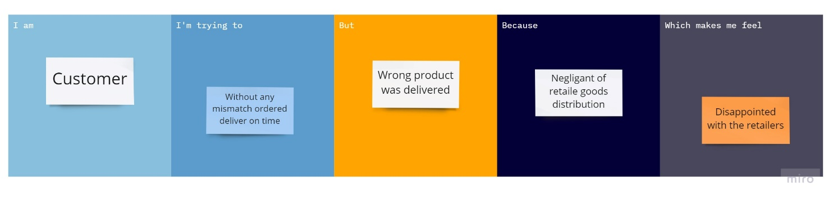

|  |  |  |  |  |  |
| --- | --- | --- | --- | --- | --- |
| **Problem Statement (PS)** | **I am (Customer)** | **I’m trying to** | **But** | **Because** | **Which makes me feel** |
| Mismatch in goods delivery | Customer | Get the ordered item on time without any mismatch | The wrong product was delivered which I not wished for | Of the negligent retail goods distribution from the inventory. | Dissatisfaction with the retail goods dealer and not trust worthy. |
| Wastage of resources due to stockpiling | Retail suppliers | Store degradable goods such as fruits and vegetables in my warehouse. | Due to stockpiling these degradable goods are subjected to decomposition. | Vegetable and fruits cannot be stockpiled more than two days. | Loss in overall business and wastage of goods |
| Error in data can lead to major loss to the retail company | E-commerce dealer | To store large amount of data such as customers order and delivery status | Due to errors in the data that leads to major loss to the company | The data are entered and analyse manually using human’s  intervention | Fallacy in data can leads to major frustration to the e-commerce manager and the company shareholders. |